|  |
| --- |
| Legacy Document |
|  |
|  |
| **SAIT** |
| **4/7/2010** |

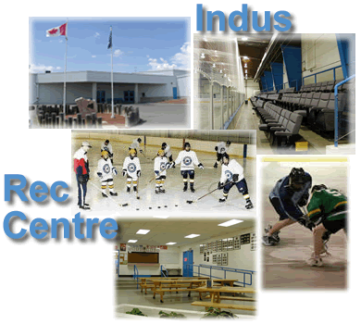

**Team Members:**

John Stuby

Jorge Pinochet

Corey Cantley

Kerri Lynch-O’Loughlin

**Client:** Indus Recreational Centre

**Instructor:** Randy Kaltenbach

Contents

Purpose of Document 7

Progress Report 1 – Indus Recreational Centre 8

Progress Report 2 – Indus Recreational Centre 10

Progress Report 3 – Indus Recreational Centre 12

Progress Report 4– Indus Recreational Centre 13

Progress Report 5 – Indus Recreational Centre 14

Progress Report 6 – Indus Recreational Centre 15

Progress Report 7 – Indus Recreational Centre 16

Progress Report 8– Indus Recreational Centre 17

Progress Report 9 – Indus Recreational Centre 18

Deployment Plan 19

IRFMS 19

Overview 20

Purpose 20

Business Context 20

Summary 20

Assumptions, Dependencies, Constraints 21

Assumptions 21

Dependencies 21

Constraints 22

Operational Readiness 23

Deployment Diagram 23

Site Preparation 23

Assessment of Deployment Readiness 24

Data Creation/Conversion 25

Training and Documentation 26

Training 26

Documentation 26

Documents 26

Documentation Activities 26

Maintenance Planning 27

Release Planning 28

Release of the Product 28

Contingency Planning 28

Testing Results 29

Presentations and Feedback 40

Indus Presentation 40

Indus Recreational Facility 40

Comparison of current and new 41

Current Scheduling System 42

New Scheduling System 43

New Scheduling System 44

New Scheduling System Online 45

Invoicing 46

Invoicing – New System 47

Facility Management 48

Navigation Old 49

Navigation New 50

Internet Connectivity 51

Scenario: Making a Booking 52

Scenario 1 (Cont…) 53

Scenario 1 (Cont…) Slide 2 54

Scenario 1 (Cont…) Slide 3 55

Scenario: Adding an Invoice 56

Scenario 2 (Cont…) 57

Scenario 2 (Cont…) Slide 2 58

Scenario 2 (Cont…) Slide 3 59

Scenario 2 (Cont…) Slide 4 60

Color Scheme 61

In Conclusion 62

Contact Information 63

Agenda 64

Indus Technical Presentation 65

Indus Recreational Facility 65

Agenda 66

Current Scheduling System 67

Facility Management 68

Invoicing 69

Navigation 70

Internet Connectivity 71

System Requirements 72

System Requirements Continued 73

Internal Structure 74

Client View 75

Technical Challenges: #1 Java Swing Module 76

Technical Challenges: #2 Integrating Programming Languages 77

Technical Challenges: #3 SAIT Firewalls 78

Solution Problem #1 79

Solution Problem #2 80

Solution Problem #3 81

Scenario Scheduling 82

Scenario Scheduling Continued 83

Scenario Scheduling Continued Slide 2 84

Scenario New Invoice 85

Scenario New Invoice Continued 86

Scenario New Invoice Continued Slide 2 87

Scenario New Invoice Continued Slide 3 88

Scenario New Invoice Continued Slide 4 89

Scenario New Invoice Continued Slide 5 90

Plan for Project Completion 91

In Conclusion 92

Contact Information 93

Agenda 94

Lessons Learned 95

Technical Concepts Learned: 95

Corey: 95

Kerri: 95

Jorge: 95

John: 96

Managerial Concepts Learned: 97

Corey: 97

Kerri: 97

Jorge: 97

John: 97

Recommendations for Future Enhancements: 99

Corey: 99

Kerri: 99

Jorge: 99

John: 99

Future Enhancements: 100

Items not designed or developed: 100

Bright Ideas: 100

## Purpose of Document

The purpose of this document is to show all the relevant reference Material used during the creation of the Indus Recreational Facility Management System (IRFMS). The reference material used includes progress reports, test plan with results, past presentations, lessons learned by all group members and future enhancements.

Through the use of the documents included in this legacy document, future programmers will be able to understand some of the logic behind the development phase of the IRFMS.

## Progress Report 1 – Indus Recreational Centre

**Group Members**:

Kerri Lynch-O’Loughlin

Corey Cantley

Jorge Pinochet

John Stuby

**Reporting Period**: From *January 11, 2010*  – To *January 26, 2010*

**Highlights**

**Team Progress**

*Laptops prepared 100% done*

*Server setup 100% done*

*Database is 50% done*

*HCI mock-ups are 100% done*

*Sequence Diagrams are 6% done*

*Design Document 60% done*

*Team Charter revision 100% done*

**Individual Progress**

* *JP worked on the Database which is 50% complete*
* *CC worked on updating the sequence diagrams which are 6% done*
* *CC also worked on the HCI’s which are 100% done*
* *JS worked on activity diagram which is 100% updated*
* *KL worked on the work assignments and scheduling which is on going.*
* *KL worked on the use case descriptions which are 50% done.*

**Team Progress Planned For The Next Reporting Period**

* *Design Document*
  + *Sequence diagrams revised 100% done*
  + *Use Case descriptions revised 100% done*
  + *Problem Domain Class Diagram revised 100%*
  + *Logic Class Diagram revision 100% done*
  + *Persistence Class Diagram revision 100% done*
  + *Formatting Fixes for Document revision 100% done*
  + *Non-functional Requirements revision 100% done*
  + *State Machine Diagram revision 100% done*
  + *Layered Architecture revision 100% done*
  + *Component Diagram 100% done*
  + *Deployment Diagram 100% done*
  + *Communication Mechanisms 100% done*
  + *System Administration 100% done*
    - *Security*
    - *Operation*
    - *Backup and Restore*
    - *Data Archival*

**Individual Progress Planned For The Next Reporting Period**

* *CC and JP will work on the Sequence diagrams and will get them 100% done*
* *JS will work on broker classes and get it 25% done*
* *KL will work on development business layer and get it 25% done*
* *CC and JP will get the UI’s 10% done*

**Issues and Concerns**

*Have been slow to start development work but are starting to pick up the pace now.*

**Gantt Chart**

* *updated*

## Progress Report 2 – Indus Recreational Centre

**Group Members**:

Kerri Lynch-O’Loughlin

Corey Cantley

Jorge Pinochet

John Stuby

**Reporting Period**: From: January 26, 2010

To: February 2, 2010

**Team Progress**

Design Document

* Sequence diagrams revised - 100% complete
* Use Case descriptions revised - 100% complete
* Problem Domain Class Diagram revised - 100% complete
* Logic Class Diagram revised - 100% complete
* Persistence Class Diagram revised – 100% complete
* Formatting Fixes for document – 100% complete
* Non-functional Requirements revised – 100% complete
* State Machine Diagram revised – 100% complete
* Layered Architecture revised – 100% complete
* Component Diagram – 100% complete
* Deployment Diagram 100% complete
* Communication Mechanisms 100% complete
* System Administration 100% complete
  + Security
  + Operation
  + Backup and Restore
  + Data Archival
* Document editing and formatting 98%

**Individual Progress**

* CC and JP worked on the Sequence diagrams and they are 100% complete
* JP worked on the Use Case Diagram and it is 100% complete
* JS worked on the System Administration descriptions for the design document and it is 100% complete
* CC and JP worked on the Persistence Class Diagrams and they are 100% complete.
* KL worked on the Use Case descriptions which are 100% complete
* KL worked on work assignments and scheduling – ongoing
* CC worked on the Problem Domain Diagram, State Machine Diagram
* KL worked on the Component Diagram and Deployment Diagram

**Team Progress Planned For The Next Reporting Period**

* Development work:
* Business Layer – 20% done
* Persistence Layer – 5%

**Individual Progress Planned For The Next Reporting Period**

* CC & KL will begin work on the Business Layer and will have it 20% completed
* JP & JS will begin work on the Persistence Layer and will have 5% of broker classes completed.

**Issues and Concerns**

Development work is just starting so we are a little behind of where we would like to be at this point

**Gantt Chart**

* updated

## Progress Report 3 – Indus Recreational Centre

**Group Members**:

Kerri Lynch-O’Loughlin

Corey Cantley

Jorge Pinochet

John Stuby

**Reporting Period**: From: February 9, 2010

To: February 16, 2010

**Team Progress**

Design Document

Document editing and formatting 100%

Design Presentation – 90% completed

**Individual Progress**

* CC, KL, JP, JS have 90% of the design presentation completed
* CC & KL worked on the Business Layer and have it 50% completed
* JP & JS worked on the Persistence Layer and have 40% of broker classes completed.

**Team Progress Planned For The Next Reporting Period**

* Design Presentation 100% completed

**Individual Progress Planned For The Next Reporting Period**

* CC & KL will begin working on the Business Layer and will have it 100% completed
* JP & JS will begin working on the Persistence Layer and will have 100% of broker classes completed.

**Gantt Chart**

* updated

## Progress Report 4– Indus Recreational Centre

**Group Members**:

Kerri Lynch-O’Loughlin

Corey Cantley

Jorge Pinochet

John Stuby

**Reporting Period**: From: February 16, 2010

To: February 23, 2010

**Team Progress**

Development Phase

Business Layer – 100% completed

Persistence Layer – 75% completed

**Individual Progress**

* CC & KL has 100% of the Business Layer completed
* JP & JS worked on the Persistence Layer, including testing, and have it 75% completed

**Team Progress Planned For The Next Reporting Period**

* Persistence Layer 100% completed
* Logic Layer 25% completed

**Individual Progress Planned For The Next Reporting Period**

* CC & KL will begin working on the Logic Layer and will have it 25% completed
* JP & JS will continue working on the Persistence Layer and will have 100% of broker classes completed.

**Gantt Chart**

* updated

## Progress Report 5 – Indus Recreational Centre

**Group Members**:

Kerri Lynch-O’Loughlin

Corey Cantley

Jorge Pinochet

John Stuby

**Reporting Period**: From: February 16, 2010

To: March 2, 2010

**Highlights**

The group is working extremely hard and have caught up to schedule

**Team Progress**

Development Phase

Business Layer – 100% completed

Persistence Layer – 95% completed

Logic Layer – 20% completed

**Individual Progress**

* CC & KL has 100% of the Business Layer completed
* JP & JS worked on the Persistence Layer, including testing, and have it 95% completed
* JP & CC & JS worked on the Logic Layer and has 20% complete

**Team Progress Planned For The Next Reporting Period**

* Persistence Layer 100% completed
* Persistence Layer Tests 100% completed
* Logic Layer 50% completed
* Logic Layer Tests 25% completed

**Individual Progress Planned For The Next Reporting Period**

CC & KL will begin working on the Logic Layer and will have it 50% completed and testing 25% completed

JP & JS will continue working on the Persistence Layer and will have 100% of broker classes completed and 100% of the testing completed.

**Gantt Chart**

* updated

## Progress Report 6 – Indus Recreational Centre

**Group Members**:

Kerri Lynch-O’Loughlin

Corey Cantley

Jorge Pinochet

John Stuby

**Reporting Period**: From: March 2, 2010

To: March 9, 2010

**Team Progress**

Development Phase

Persistence Layer – 100% completed

Logic Layer – 40% completed

**Individual Progress**

* JP & JS worked on the Persistence Layer, including testing, and have it 100% completed
* JP & CC & JS worked on the Logic Layer and has 40% complete

**Team Progress Planned For The Next Reporting Period**

* Logic Layer 60% completed and 30% tested.
* HCI Layer 10% completed.

**Individual Progress Planned For The Next Reporting Period**

* JP & KL will begin working on the Logic Layer and will have it 50% completed and testing 25% completed
* CC & JS will continue working on the HCI Layer and will have 10% completed

**Gantt Chart**

* updated

## Progress Report 7 – Indus Recreational Centre

**Group Members**:

Kerri Lynch-O’Loughlin

Corey Cantley

Jorge Pinochet

John Stuby

**Reporting Period**: From: March 2, 2010

To: March 16, 2010

**Highlights**

We have caught up with our scheduled plan.

**Team Progress**

HCI – 90%

Logic layer – 100%

Documentation – 40%

Web Component – 60%

**Individual Progress**

* CC & JP worked on HCI’s and it is 90 %
* CC & JP worked on Logic layer and it is 100%
* JS worked on documentation and it is 40%
* KL worked on web component and it is 60%

**Team Progress Planned For The Next Reporting Period**

* Fully finish HCI – 100%
* Documentation and testing – 90%
* Finish Website component – 100%

**Individual Progress Planned For The Next Reporting Period**

* KL will work on website components
* JS will work on documentation and testing
* CC & JP will work on finishing HCI’s and system

**Gantt Chart**

* updated

## Progress Report 8– Indus Recreational Centre

**Group Members**:

Kerri Lynch-O’Loughlin

Corey Cantley

Jorge Pinochet

John Stuby

**Reporting Period**: From: March 24, 2010

To: March 30, 2010

**Team Progress**

HCI – 95%

Documentation – 90%

Web Component – 75%

Junit testing – 5%

**Individual Progress**

* CC & JP worked on HCI’s and it is 95 %
* JS worked on documentation and it is 90%
* JS worked on testing and it is 5%
* KL worked on web component and it is 75%

**Team Progress Planned For The Next Reporting Period**

* Fully finish HCI – 100%
* Documentation – 100%
* Testing – 20%
* Finish Website component – 100%

**Individual Progress Planned For The Next Reporting Period**

* KL will work on website components and get it 100%
* JS will work on documentation and get it 100%
* JS & CC will work on testing and get it 20%
* CC & JP will work on finishing HCI’s

**Gantt Chart**

* Updated

## Progress Report 9 – Indus Recreational Centre

**Group Members**:

Kerri Lynch-O’Loughlin

Corey Cantley

Jorge Pinochet

John Stuby

**Reporting Period**: From: March 30, 2010

To: April 6, 2010

**Team Progress**

HCI – 97%

Code documenting – 100%

Acceptance Test Plan – 100%

Web Component – 95%

Testing – 25%

**Individual Progress**

* CC, JP, & KL worked on HCIs and it is 97% completed.
* JS worked on code documenting and it is 100% completed.
* JS & JP worked on the Acceptance Test Plan and it is 100% completed.
* JS worked on testing and it is 25% completed.
* KL worked on web component and it is 95% completed.
* KL worked on the User Guide and it is 70% completed.

**Team Progress Planned For the Next Reporting Period**

* Fully finish HCI – 100%
* System & User Guide Documentation – 50%
* Testing – 40%
* Finish Website component – 100%

**Individual Progress Planned For the Next Reporting Period**

* KL will work on website components and get it 100% complete.
* JS & KL will work on documentation
  + System document will be 25% completed
  + User Guide document will be 95% completed
* JS, CC & KL will work on testing and get it 40% completed.
* CC, JP will work on finishing HCIs

**Gantt Chart**

* updated

## Deployment Plan

SAIT

## IRFMS

|  |  |
| --- | --- |
|  | April 10, 2010 |

|  |  |  |
| --- | --- | --- |
| **Approver Name** | **Signature** | **Date** |
| John Stuby |  | April 10, 2010 |
| Jorge Pinochet |  | April 10, 2010 |
| Corey Cantley |  | April 10, 2010 |
| Kerri Lynch O'Loughlin |  | April 10, 2010 |

## Overview

### Purpose

The purpose of the deployment plan is to outline how the IRFMS will be implemented, including software and training.

### Business Context

The Indus Recreational Facility staff will have a more advanced version of their current management system; this will help increase productivity by increasing the efficiency of staff tasks in their day to day activities. It will cut down on written work by providing online functionality to cover specific tasks that would otherwise have to be accomplished by pen and paper.

The use of the new system will help the Indus Recreational Facility by giving the users new functionality. This will include: exporting, printing and emailing options for invoices, thus reducing the requirement of having to manually generate them.

### Summary

The IRFMS will require many activities to get the finished product into deployment, this includes:

* Testing all components of the program through the use of a test plan
* User Guide: ensuring that the user guide is up to date and detailed enough to help any level of user will be able to use the Indus System effectively.
* Beta runs of the installation process to ensure that the program can be installed on a different computer without any problems.

## Assumptions, Dependencies, Constraints

### Assumptions

The current system will enable let users:

* View schedules for a specific facility for a specific time frame.
* View employees
* View clients
* View organizations
* View rates
* View additional Charges
* View facilities
* View invoices
* Creating bookings for a specific facility at a specific time
* Create new employees
* Create new clients
* Create new organizations
* Create new rates
* Create new additional charges
* Create new facilities
* Create a invoice based on multiple bookings for a client
  + From the invoice created you have the option to:
    - Print the invoice
    - Email the invoice to the client or organization
    - Export the invoice in a cvs format to excel
* Delete employees
* Delete clients
* Delete organizations
* Delete rates
* Delete additional charges
* Delete facilities
* Modify employee information
* Modify client information
* Modify organization information
* Modify rate information
* Modify additional charge information
* Modify facility information

### Dependencies

The IRFMS is dependent on:

* MySQL server

### Constraints

Constraints that affect the IRFMS ability to be deployed include:

* Unintended errors within system
* Limited hardware such as insufficient ram
* Inaccurate installation guide

## Operational Readiness

### Deployment Diagram

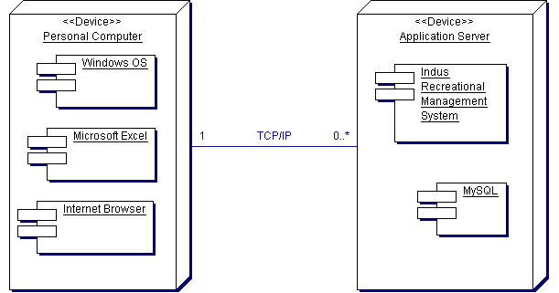

The Windows operating system along with Microsoft Excel and the internet browser of the users choosing will all reside on the personal computer of the Indus Recreational Facility staff members.

The IRFMS and MySQL will be located on an application server at the Indus Recreational Facility, the System and personal computer will be connected through a TCP/IP connection.

### Site Preparation

The preparation required to ensure that the system works on the required system properly includes:

* An in-depth installation guide to ensure an easy and efficient way to install the program on the user’s computer
* An in-depth user manual that explains the processes of using the IRFMS effectively and efficiently.
* An easy to use installation CD, this will run the script necessary to run the program on the user’s computer.

### Assessment of Deployment Readiness

Currently the methods used to ensure that deployment of IRFMS is up to date and efficient include:

* Test plan: this ensures that all areas of the program work as specified.
* User manual: this is used to test the system by following the instructions step by step to ensure that they are easy to use, efficient and have the same result as specified.
* Installation process: this is tested regularly to ensure that the system can be easily installed on other computers.

## Data Creation/Conversion

The IRFMS allows the Staff of the Indus Recreational Facility to be able to create, update, view, delete multiple components of the system, such as:

* View schedules for a specific facility for a specific time frame.
* View employees
* View clients
* View organizations
* View rates
* View additional Charges
* View facilities
* View invoices
* Creating bookings for a specific time for a specific facility
* Create new employees
* Create new clients
* Create new organizations
* Create new rates
* Create new additional charges
* Create new facilities
* Create a invoice based on multiple bookings for a client
  + From the invoice created you have the option to:
    - Print the invoice
    - Email the invoice to the client or organization
    - Export the invoice in a cvs format to excel
* Delete employees
* Delete clients
* Delete organizations
* Delete rates
* Delete additional charges
* Delete facilities
* Modify employee information
* Modify client information
* Modify organization information
* Modify rate information
* Modify additional charge information
* Modify facility information

All the information entered when creating or updating any of the above components is validated as soon as the information is inputted to ensure that it is in the correct format and has the required information.

## Training and Documentation

### Training

The IRFMS will come with a user guide that explains the main functions of the program in an easy to follow format.

### Documentation

All the IRFMS code is documented to help future programmers be able to maintain and update the system.

Other documentation that s included for the IRFMS is the Test Plan This tests the main components of the system to ensure that they work as described. This will assist future developers of the system in adding extra enhancements as they will be able to see how the code performs under certain conditions.

The last document is the User Guide, this will introduce users to the system. The guide is in depth and shows how each component of the system interacts with one another in a systematic manner. It also shows the user how certain components of the system interact with each other on the final product.

### Documents

The installation document with instructions on how to install the IRFMS system will be included in the:

* The User guide: this guide will help the user step by step throughout all important components of the system; it will also provide help in certain areas if the user is having difficulty.

### Documentation Activities

The activities required for the test plan include:

* Multiple tests of system
* Testing each field to ensure quality
* Testing the system with invalid information
* Testing the creation, deletion and updating of different components such as clients, employees, etc.

The activities required for the User Guide include:

* Multiple run through of using the system in different environments.
* Ensuring that step by step instructions are exactly the same as actual actions in the system.
* Ensuring that the guide is written in a clear and easy to understand fashion to be able to help users of any level.

## Maintenance Planning

The entire system is documented this will assist in understanding what every class’s main function is supposed to be. Each method within the class and all variables are documented to help explain the purpose and logic behind how the IRFMS was designed and built.

By documenting throughout the system it helps convey the reasoning behind why it was built this way. It will help any future programmers figure out the connections between classes and how everything works together.

## Release Planning

### Release of the Product

The process for releasing the IRFMS to users is to ensure that all components that work are polished and work completely, ensuring that any components that currently do not meet standards of quality are commented out or made inactive to be worked upon on a later date.

### Contingency Planning

The contingency plan in case a error occurs while show casing the IRFMS is to be able to move onto different components if one or more components fail to work.

## Testing Results

| **Client**: Indus Recreational center |  |
| --- | --- |
| **System**: Indus Recreational Center Scheduling System |  |
| **Objective**:  Verify that when a booking is created, all information is updated in the booking table located in database | |
| **Tester Name:** Kerri Lynch-O’Loughlin | |
| **Developer Name:** John Stuby | |

| **Component**: Create booking | | **Test Date:** |
| --- | --- | --- |
| **Test** | **Description** | **Actual Result** |
| 1. | *Select free time in schedule for facility*  **Procedure**:  Open the program  -The application should display the home page  Log in with a valid username and password  -Login with username as kerri and password as password  Click on the schedule tab  -Located on the top left in the menu bar  Click on a free time on the schedule  -Click on white space of the timetable displayed  **Expected Result**:  Opens up the booking screen  -A popup menu should appear with empty fields  -The time fields however will auto fill | The Booking screen is opened |
| 2. | *Fill in all information in booking screen*  **Procedure**:  Fill in all available fields in booking screen  -Fill in fields as follows:  -given name : test  -surname: test  -client: testClient  -Event name: testEvent  -BookingType: Hockey Game  -Rate: PrimeTime Ice 1  -Guest Count: 100  -Start time: N/A  -Length: 60 minutes  -Setup time: N/A  -Teardown Time: N/A  -Additional Charges: Ctrl click each of the following:  -Pop Fountain  -Ice Machine  **Expected Result**:  All fields are filled in  -Fields should contain information the user has input | All fields are filled in, Selected additional charges are highlighted |
| 3. | *Click on save to update schedule to show new booking*  **Procedure**:  Click on save to update schedule and return to main schedule page for the selected facility  -The booking created should appear with appropriate time on the time schedule  **Expected Result**:  Save: updates schedule with new booking and returns to the schedule page for selected facility  -The time schedule from the booking will be filled into the schedule and colored red | On main schedule page, new booking is created for specified time frame with requested event name |
| 4. | *Click on delete to delete current booking and return to previous screen*  **Procedure:**  Click on delete to delete current booking and return to main schedule page for the selected facility  -Select the booking you just created. Click on the delete button  **Expected Result:**  Select the previously created booking  Click on the “delete” button: deletes current booking and return to main schedule page for the selected facility  -The time schedule will no longer display the booking that was scheduled | Returned to previous screen |

|  |  |
| --- | --- |
| **Comments**: | |
| **Client Signature of Approval**: | |
| **IT Use Only:**  Redesign Complete: 🞏 Yes 🞏 No  Retest Complete: 🞏 Yes 🞏 No  Details if Retest not complete: | |
| **Date:** | |
| **Developer Name and Signature:** | |
| **Client**: Indus Recreational Center |  |
| **System**: Indus Recreational Center Scheduling System |  |
| **Objective**:  Verify that invoice information is returned to the invoice screen and proper exporting options are taken | |
| **Tester Name:** Kerri Lynch-O’Loughlin | |
| **Developer Name:** John Stuby | |

| **Component**: Create Invoice | | **Test Date:** March 27, 2010 |
| --- | --- | --- |
| **Test** | **Description** | **Actual Result** |
| 1. | *Select bookings to add to invoice*  **Procedure**:  Open the program  -The application should display the home page  Log in with a valid username and password  -Login with kerri and password  Click on the accounting tab  -Located on the menu bar, top-left  Search for a client  -Use the available search box located by client and type in “Georgie Fisher”  Click on correct client  **Expected Result**:  Opens up the invoice screen  -Two tables appear with available bookings and booking included on invoice | Invoice screen is opened |
| 2. | *Click on the selected bookings*  **Procedure**:  Select appropriate bookings available in booking table  Once all bookings selected  - Ctrl click the first 3 bookings on the list  -Click the *add to invoice* button  **Expected Result**:  All bookings selected will move from bookings table to invoice table | Selected bookings are moved from booking table to invoice table. |
| 3. | *Remove unnecessary bookings*  **Procedure:**  Select unnecessary bookings from invoice table  -Click the remove booking button  **Expected Result:**  All bookings selected will be removed from invoice table and put back in bookings table | Removes the unnecessary bookings selected from the invoice table, and returns them to the booking table. |
| 4. | *Save the invoice*  **Procedure**:  Click on the save button  -Located at the bottom of the screen  **Expected Result**:  Invoice list will be updated in accounting list | Invoice list is updated to include the new invoice |
| 5. | *Select option to pay for invoice*  **Procedure**:  Click on the due date located in the paid column  **Expected Result**:  Payment window pops up  -First field shows payment amount for invoice  -Second field is open allowing the user to choose amount to pay. | Payment window pops up, the first field shows required payment, second field is for the user to input the amount they want to pay for invoice at current time |
| 6. | *Click on the save*  **Procedure**:  Click on save to update paid column in invoice table and return to previous page  **Expected Result**:  Return to accounting page with updated information | Returns to the accounting page with updated information for the invoice. The information in the paid column will be updated to paid if the entire amount of invoice was paid. |
| 7. | *Delete the invoice*  ***Procedure:***  Click on the invoice created earlier.  Click on the delete button if invoice is not to be completed  -Located at the bottom of the screen  **Expected Result:**  Invoice will be deleted and the user will be returned to accounting screen | Invoice is deleted and user is returned to accounting screen. |
| 8. | *Print an invoice*  **Procedure**:  Click on print icon  Select printer MD201  **Expected Result**:  Invoice is sent to printer. Invoice printed | Printer menu pops up, after selecting which printer to print to, the invoice is sent to the printer. |
| 9. | *Email an invoice*  **Procedure**:  Click on email icon  **Expected Result**:  Invoice is emailed to selected customer | Invoice is emailed to selected customer |
| 10. | *Export to Excel*  **Procedure**:  Click on invoice icon  **Expected Result**:  Invoice is exported to excel, it is exported in CSV format | Invoice is exported to excel, it is exported in a CSV format. |
| **Comments**: | | |
| **Client Signature of Approval**: | | |
| **IT Use Only:**  Redesign Complete: 🞏 Yes 🞏 No  Retest Complete: 🞏 Yes 🞏 No  Details if Retest not complete: | | |
| **Date:** | | |
| **Developer Name and Signature:** | | |

| **Client**: Indus Recreational Center |  |
| --- | --- |
| **System**: Indus Recreational Center Scheduling System R1.0 |  |
| **Objective**:  Verify that schedule is generated correctly and shows all created bookings | |
| **Tester Name:** Kerri Lynch-O’Loughlin | |
| **Developer Name:** John Stuby | |

| **Component**: Generate Schedule | | **Test Date:** March 27, 2010 |
| --- | --- | --- |
| **Test** | **Description** | **Actual Result** |
| 1. | *Select free time in schedule for facility*  **Procedure**:  Open the program  -The application should display the home page  Log in with a valid username and password  -Login with username as test and password as password  Click on the *Schedule tab* button.  -Click of the Schedule tab on the top menu bar  -Select a different facility: Banquette Hall  -Select a monthly time view for next month  **Expected Result**:  Opens up the schedule for the selected facility and timeframe | Opens up schedule for the selected facility and time frame |
| 2. | *Select an existing booking*  **Procedure**:  Click on booking in the schedule for the requested facility  -Click on a red booking called “changeThis”  **Expected Result**:  Brings up information on selected booking  -The booking details , will now be displayed | Brings up information on selected booking  -The booking details, will now be displayed |
| 3. | *Change existing booking*  **Procedure**:  Inside of booking screen change information if necessary, change first name, surname, address  -Change event title to testing  **Expected Result**:  The updated details of the booking will be changed | Booking being updated will have details that were changed updated |
| 4. | *Save changed booking*  **Procedure**:  Select save button  -Single click upon the button labeled “Save”  **Expected Result**:  Updates booking information and schedule for the selected facility  -The booking that was previously selected will now be updated | Updates booking information and schedule for the selected facility  -The booking that was previously selected will now be updated |
| 5. | *Delete existing booking*  **Procedure**:  Inside of booking screen delete booking  -While in the detailed booking notes select the delete button  **Expected Result**:  Deletes booking from schedule for facility and returns to schedule with updated bookings  -The schedule will be updated and the free time, white space, will be displayed where the booking use to take place | Deletes booking from schedule for facility and returns to schedule with updated bookings  -The schedule will be updated and the free time, white space, will be displayed where the booking use to take place |
| 6. | *Create new booking for facility for schedule*  **Procedure**:  Select empty timeframe for selected facility  -Select white space that is not colored in  **Expected Result**:  Opens up new booking screen  -A popup screen will prompt you for event details | Opens up new Booking screen.  - A popup screen will prompt for event details |
| 7. | *Create new booking*  **Procedure**:  Fill in all requested fields for booking  -Fill in fields as follows:  -given name : test  -surname: test  -client: testClient  -Booking Type: Wedding  -Rate: Night Banquette Standard  -Guest Count: 300  -Start time: N/A  -Length: 60 minutes  -Setup time: N/A  -Teardown Time: N/A  -Additional Charges: Ctrl-click each of the following:  -Bar Service  -Bar BQ  **Expected Result**:  All selected fields are filled  -There should no longer be anymore blank spaces unless previously indicated. | All selected fields are filled  -There should no longer be anymore blank spaces unless previously indicated. |
| 8. | *Save new booking*  **Procedure**:  Click on save button  -In the details popup menu, select the button named “save”  **Expected Result**:  New booking is created  Schedule for facility is updated to include new booking | New booking is created  Schedule for facility is updated to include new booking |
| 9. | *Delete Booking*  **Procedure**:  Click on the the previously created booking  Click on *delete*  -In the booking details popup menu, select the button named “delete”  **Result**:  All fields are set to original state and user is returned to previous screen  -The schedule will update with whitespace where the booking use to be in. | All fields are set to original state and user is returned to previous screen  -The schedule will update with whitespace where the booking use to be in. |
| **Comments**: | | |
| **Client Signature of Approval**: | | |
| **IT Use Only:**  Redesign Complete: 🞏 Yes 🞏 No  Retest Complete: 🞏 Yes 🞏 No  Details if Retest not complete: | | |
| **Date:** | | |
| **Developer Name and Signature:** | | |

## Presentations and Feedback

## Indus Presentation

### Indus Recreational Facility

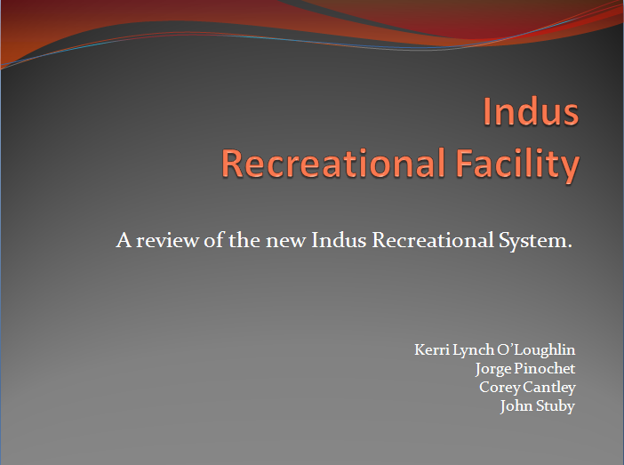

### Comparison of current and new

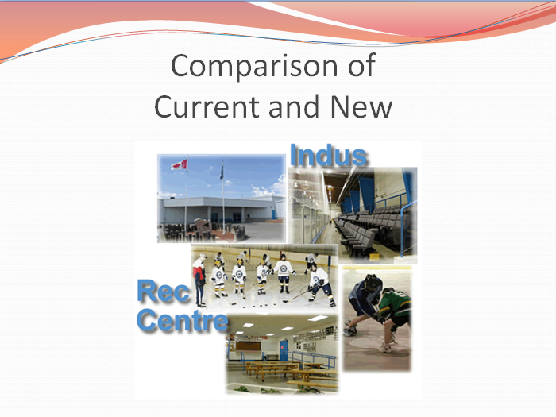

### Current Scheduling System

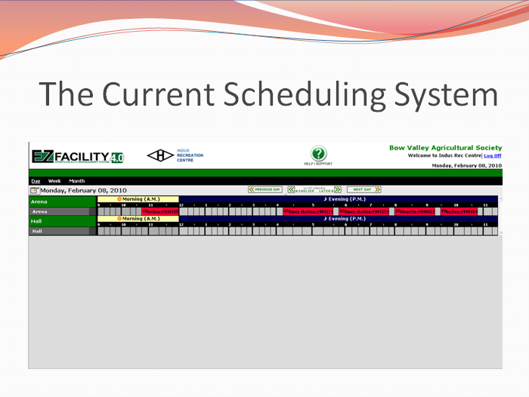

### New Scheduling System

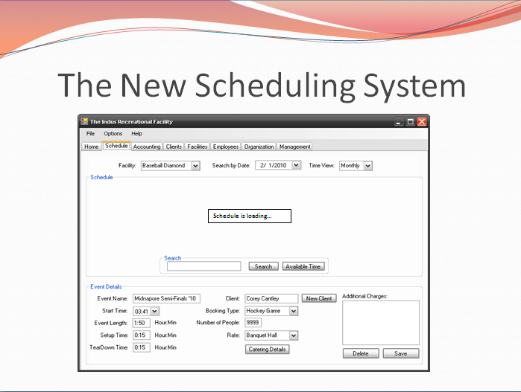

### New Scheduling System

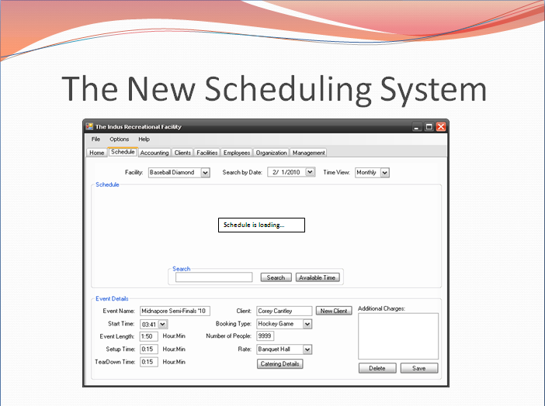

### New Scheduling System Online

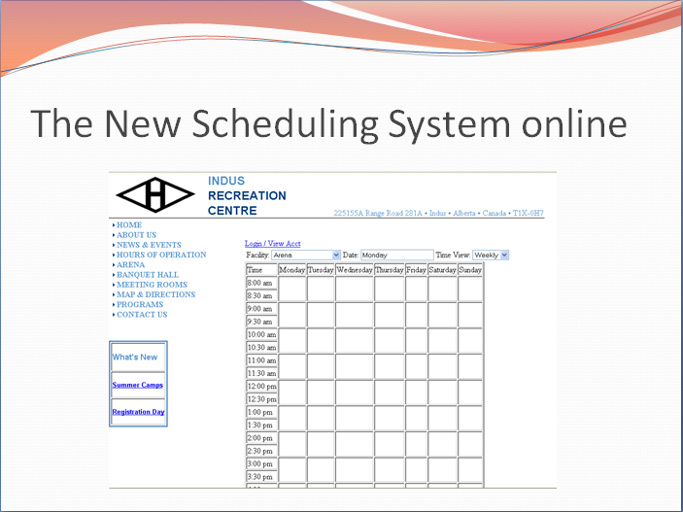

### Invoicing

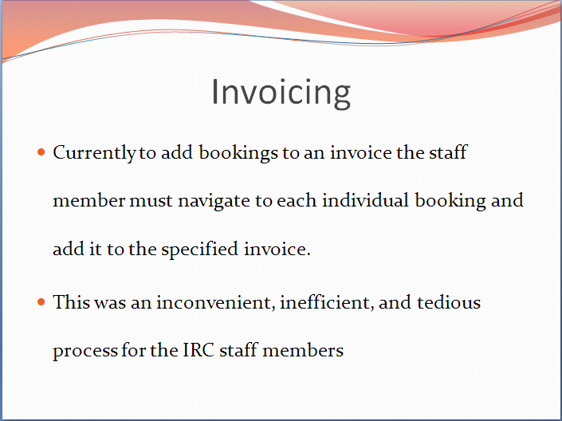

### Invoicing – New System

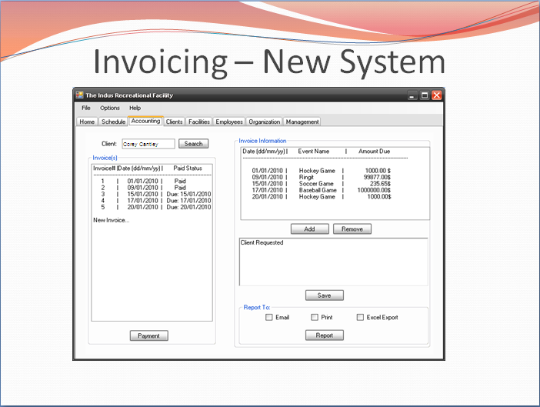

### Facility Management

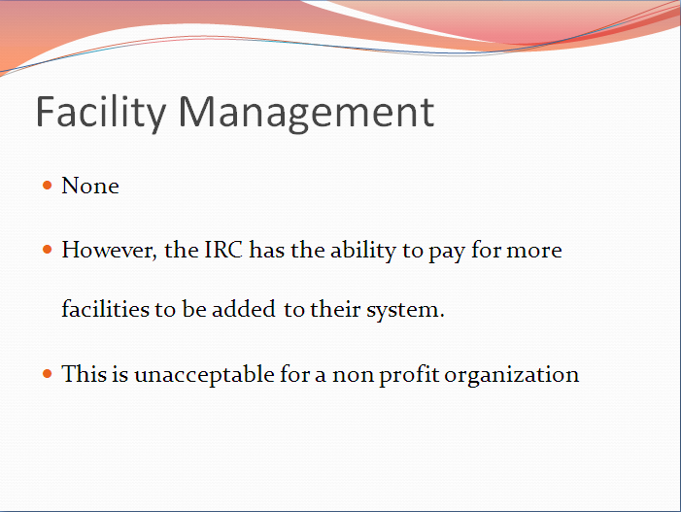

### Navigation Old

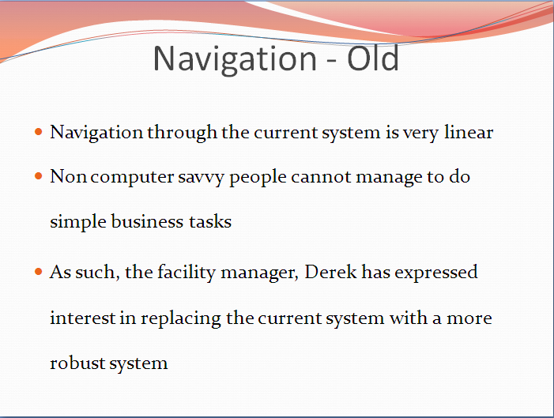

### Navigation New

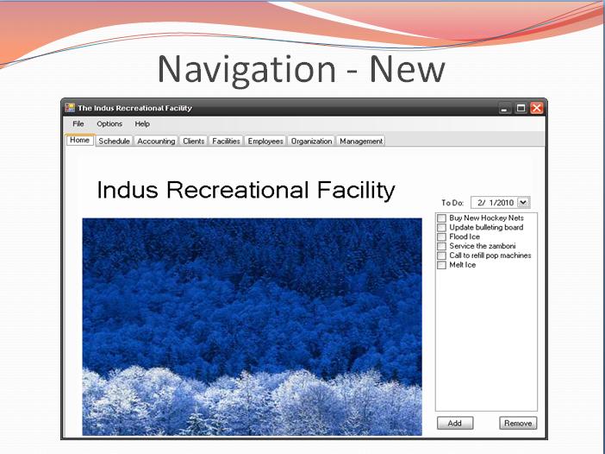

### Internet Connectivity

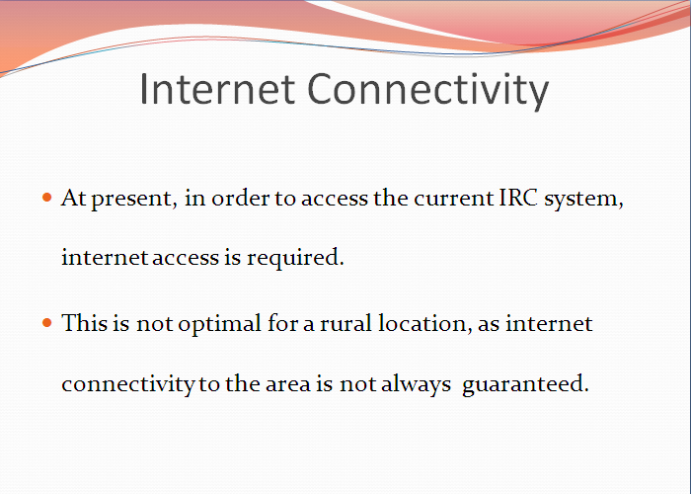

### Scenario: Making a Booking

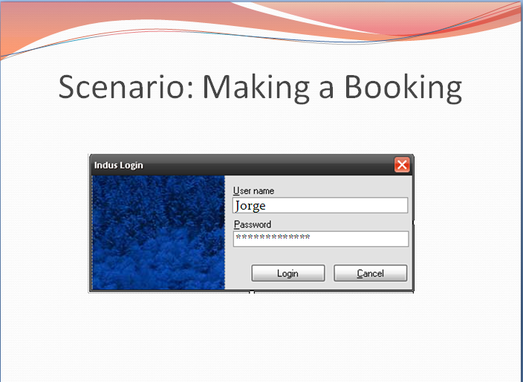

### Scenario 1 (Cont…)

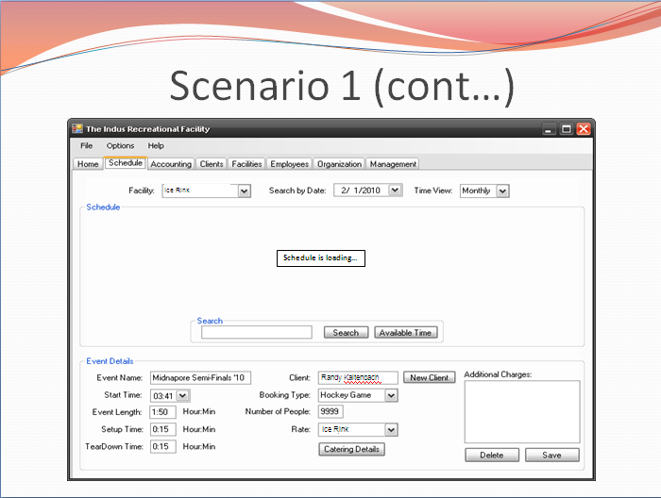

### Scenario 1 (Cont…) Slide 2

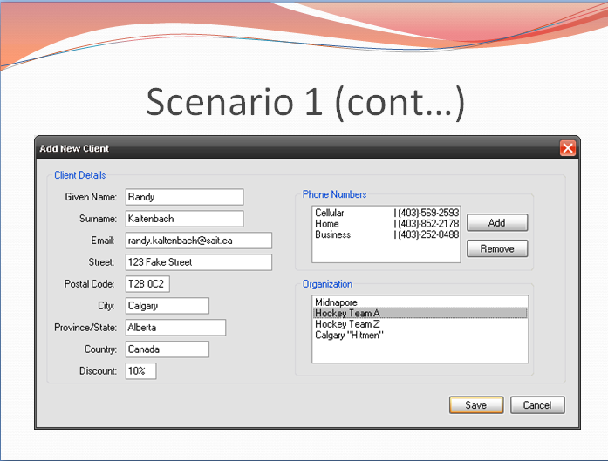

### Scenario 1 (Cont…) Slide 3

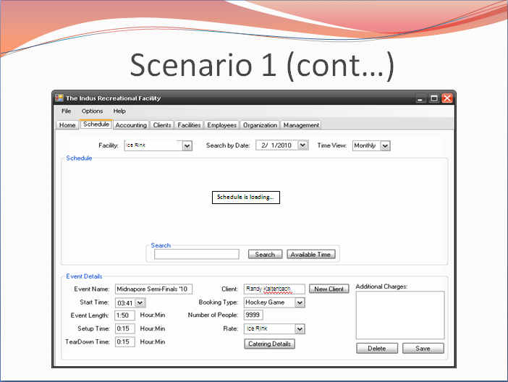

### Scenario: Adding an Invoice

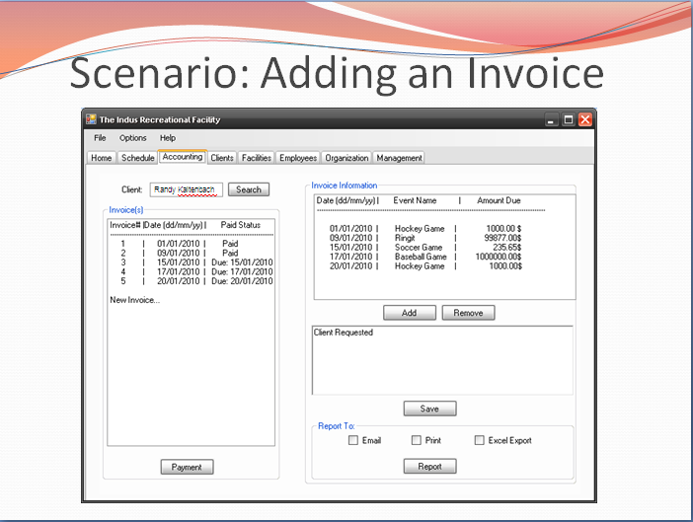

### Scenario 2 (Cont…)

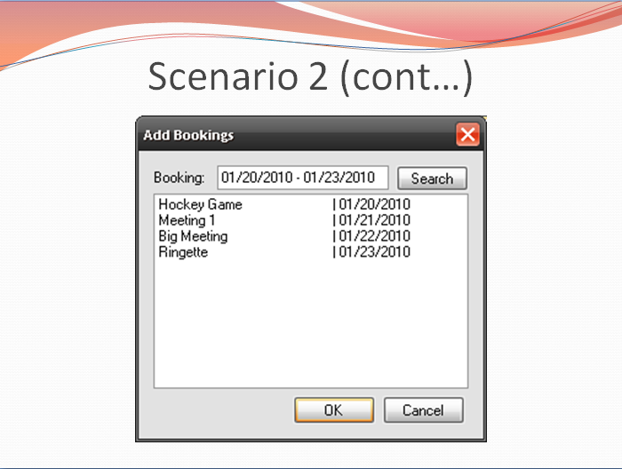

### Scenario 2 (Cont…) Slide 2

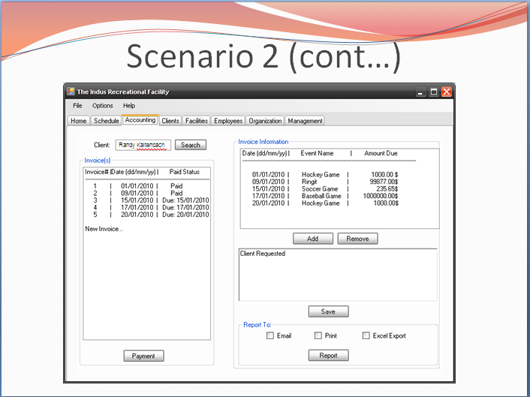

### Scenario 2 (Cont…) Slide 3

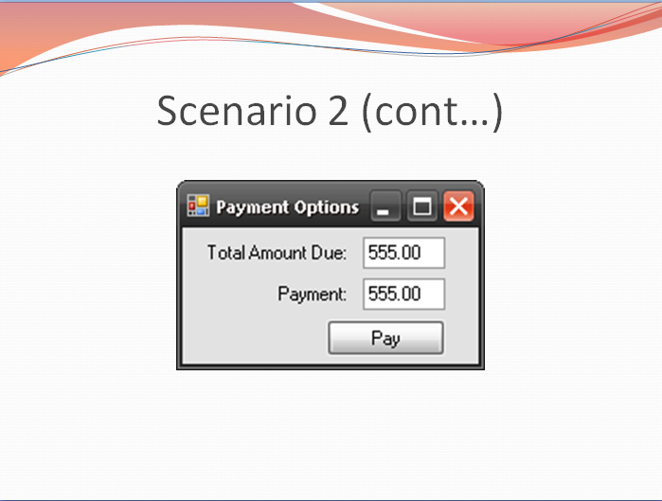

### Scenario 2 (Cont…) Slide 4

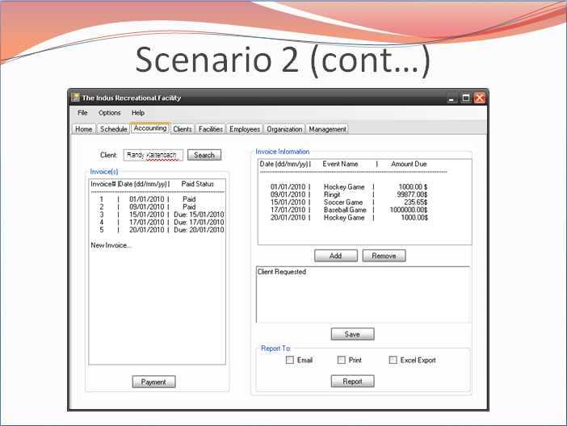

### Color Scheme

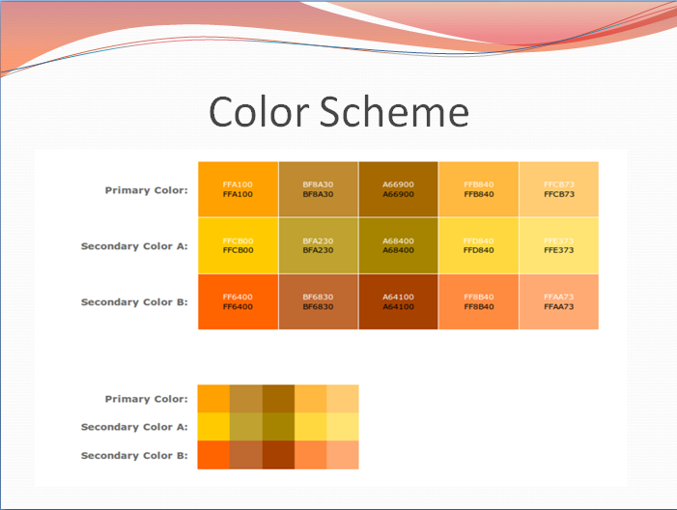

### In Conclusion

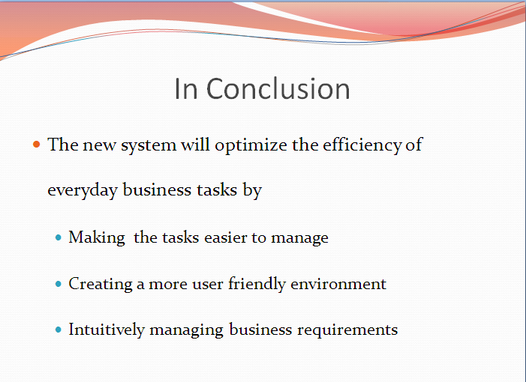

### Contact Information



### Agenda

Agenda

Indus Recreational Facility Board of Approval

February 10, 2010

1:00 pm – 2:00 pm

Present: Kerri Lynch O’Loughlin Corey Cantley Randy Kaltenbach

John Stuby Jorge Pinochet

Call To Order – Randy has called this meeting to go through the design of the new Indus Recreational Facility.

Approval of Minutes – Randy has approved the minutes, seconded by the SAIT management has approved these minutes.

Board Action Required – The Indus group is seeking approval to move forward with the design and implementation of the new system.

Items for General Discussion –

* Comparison and Standards between the current and new systems.
  + Scheduling
  + Invoice
  + Facility Management
  + System Navigation
  + Internet Connectivity
* Scenarios
  + Schedule
  + Invoice
* Colour Scheme

Adjournment- Having no further business to conduct, the meeting will be adjourned at 2:00 p.m. on motion duly made and seconded.

Submitted by

Jorge Pinochet

John Stuby

February 10, 2010

## Indus Technical Presentation

### Indus Recreational Facility



### Agenda

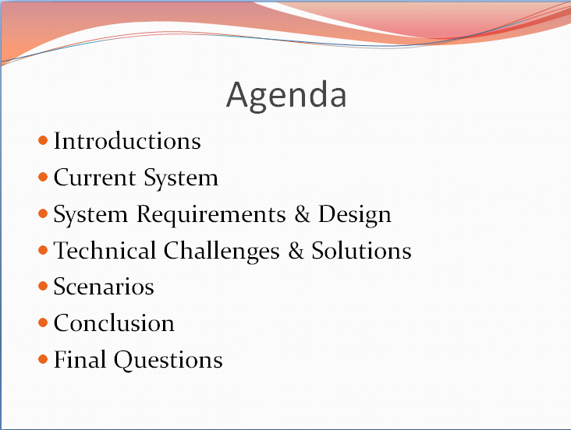

### Current Scheduling System

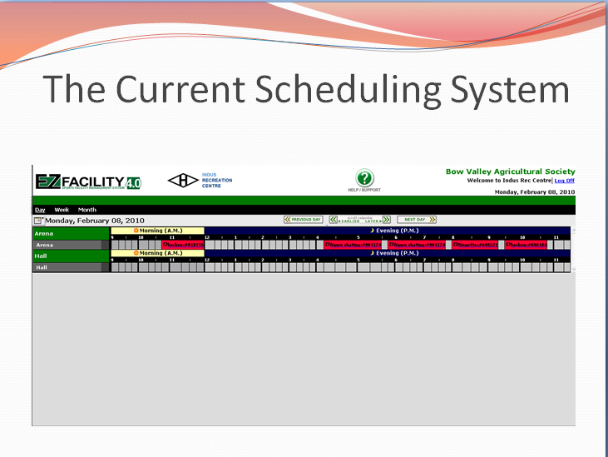

### Facility Management

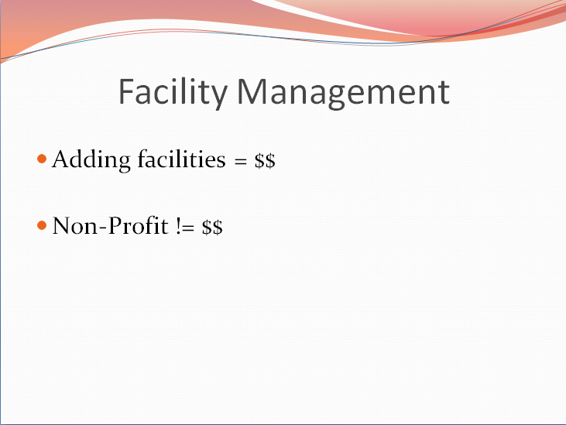

### Invoicing

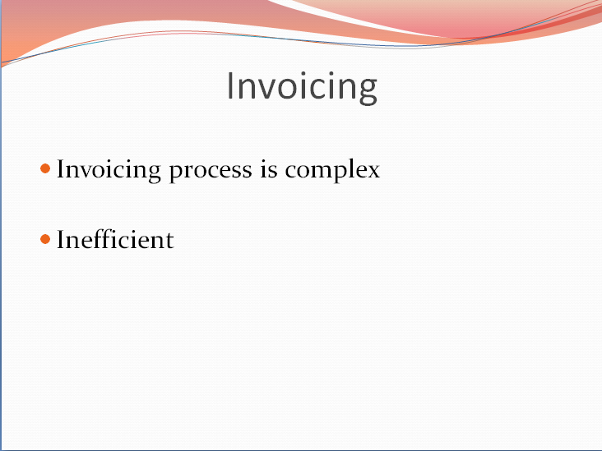

### Navigation

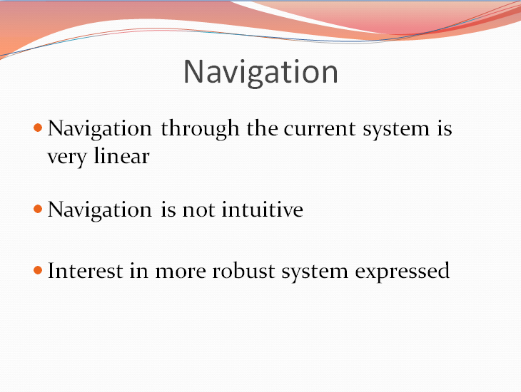

### Internet Connectivity

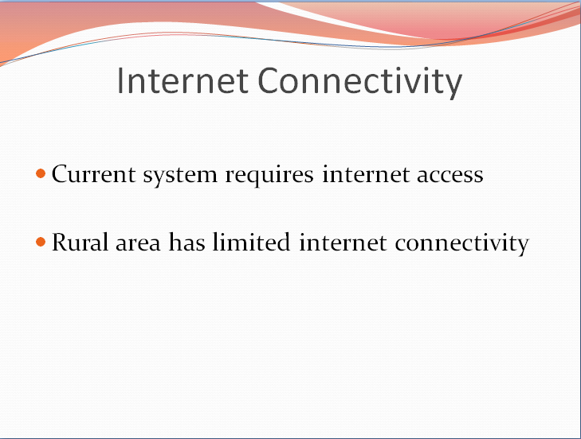

### System Requirements

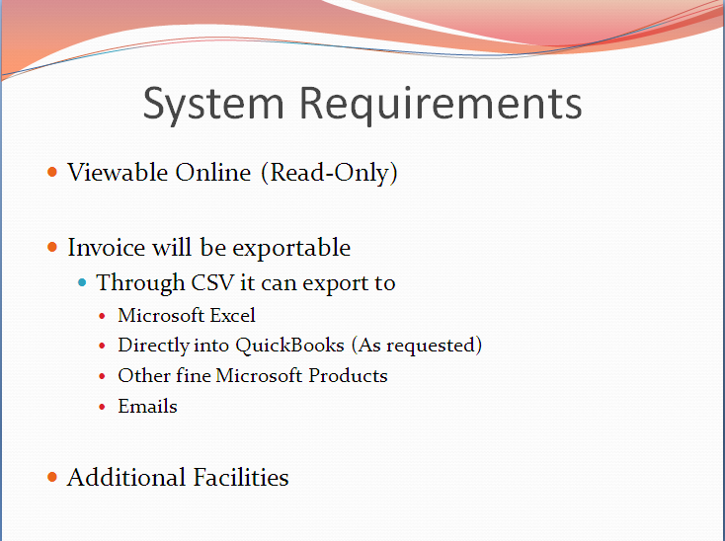

### System Requirements Continued

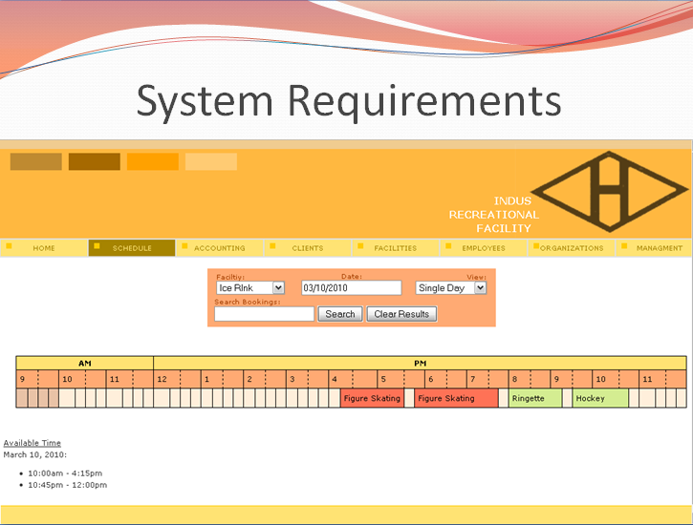

### Internal Structure

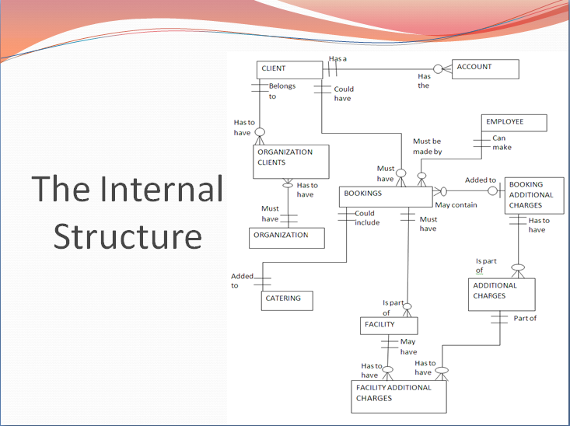

### Client View

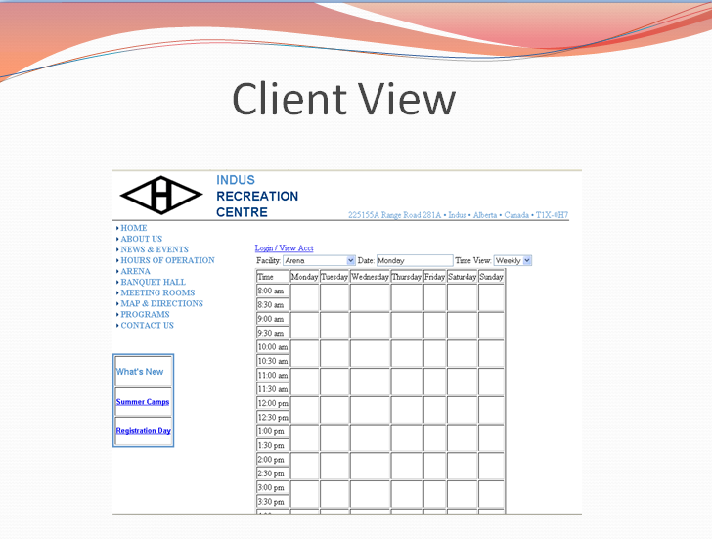

### Technical Challenges: #1 Java Swing Module

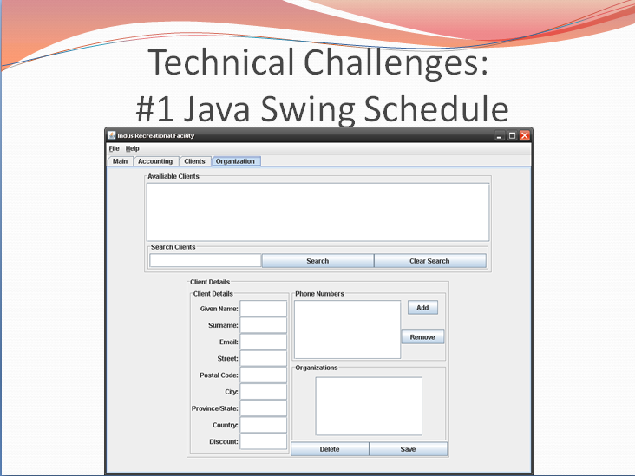

### Technical Challenges: #2 Integrating Programming Languages

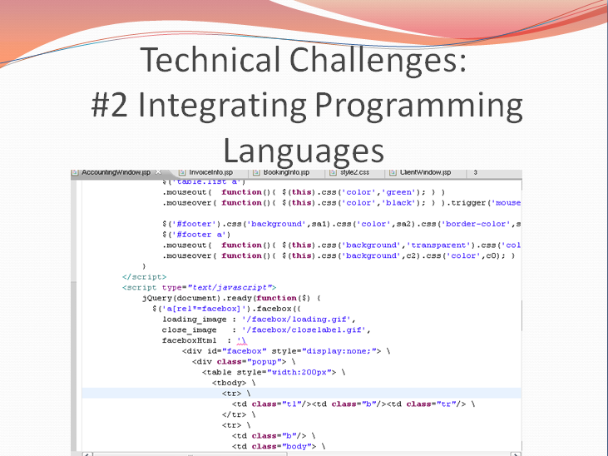

### Technical Challenges: #3 SAIT Firewalls

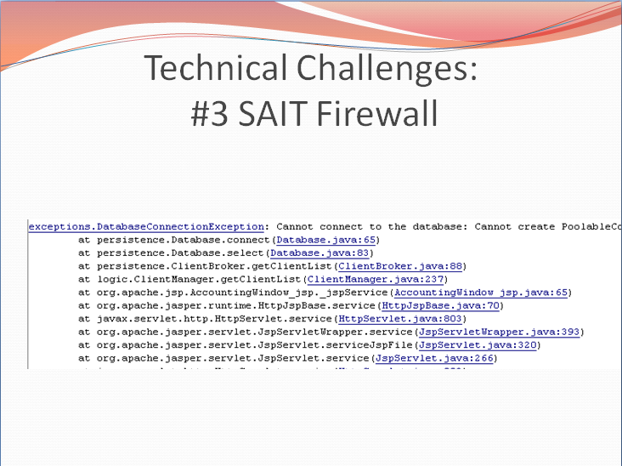

### Solution Problem #1

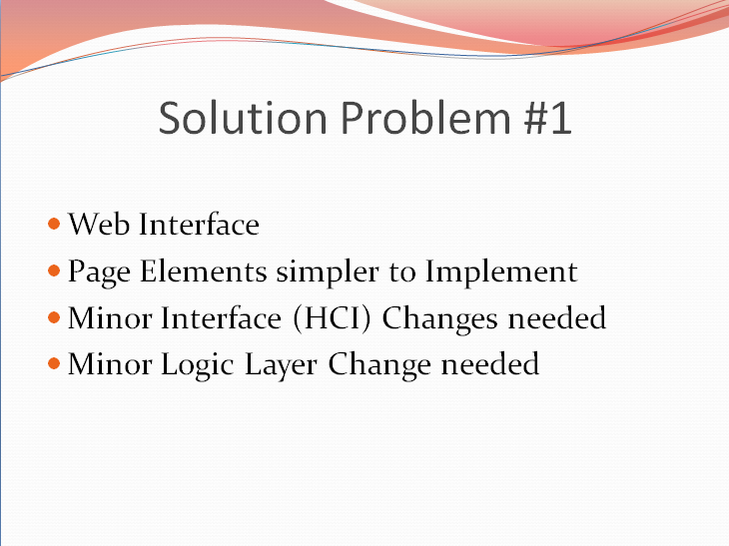

### Solution Problem #2

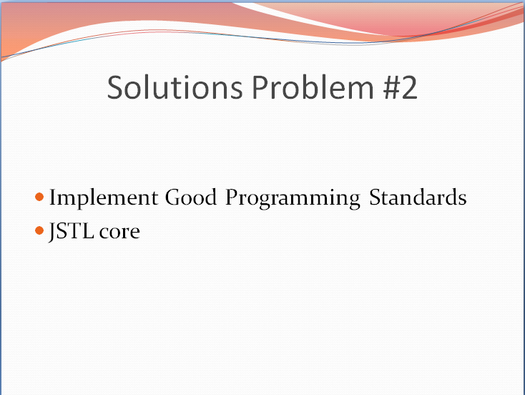

### Solution Problem #3

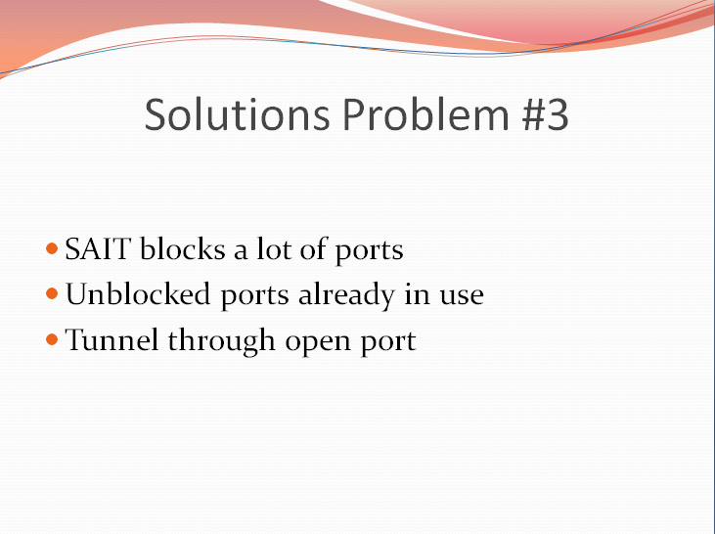

### Scenario Scheduling

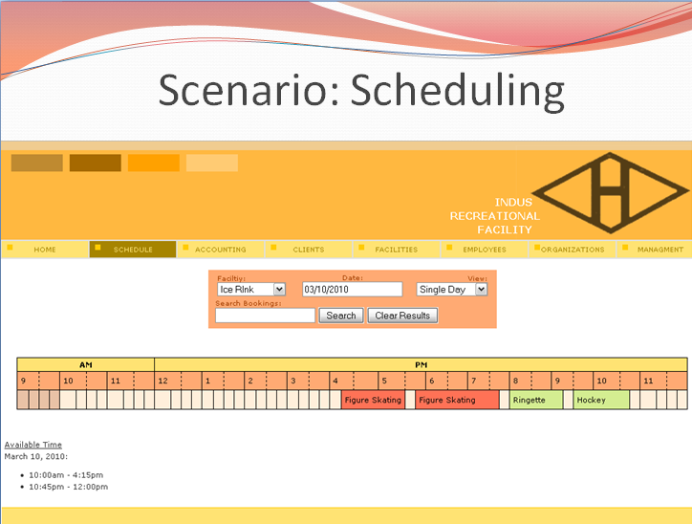

### Scenario Scheduling Continued

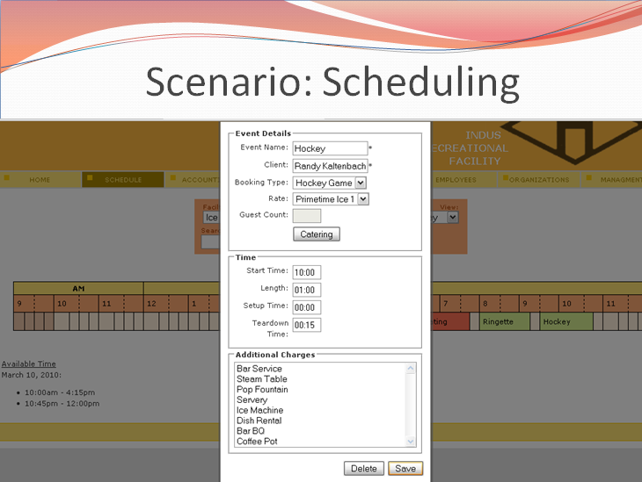

### Scenario Scheduling Continued Slide 2

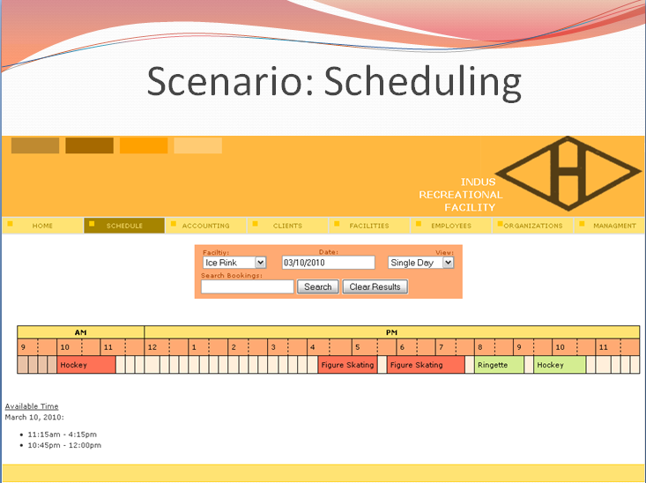

### Scenario New Invoice

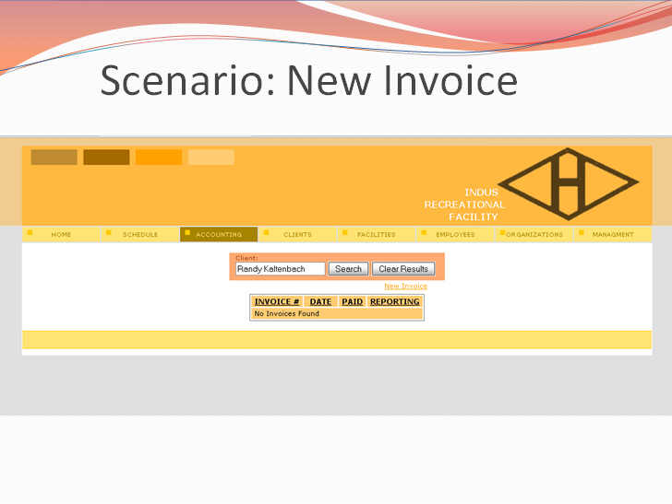

### Scenario New Invoice Continued

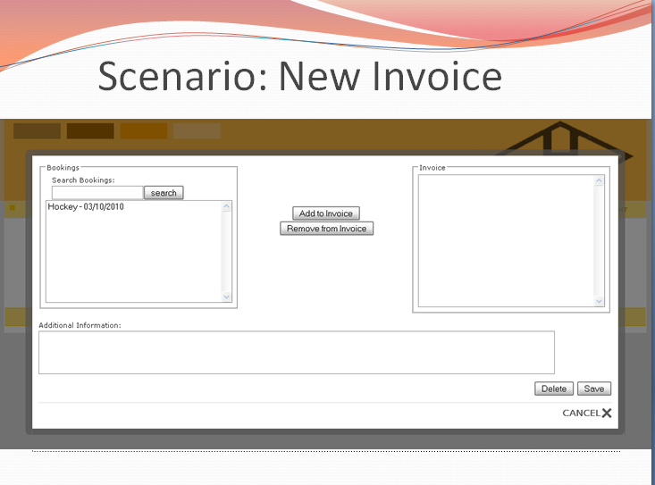

### Scenario New Invoice Continued Slide 2

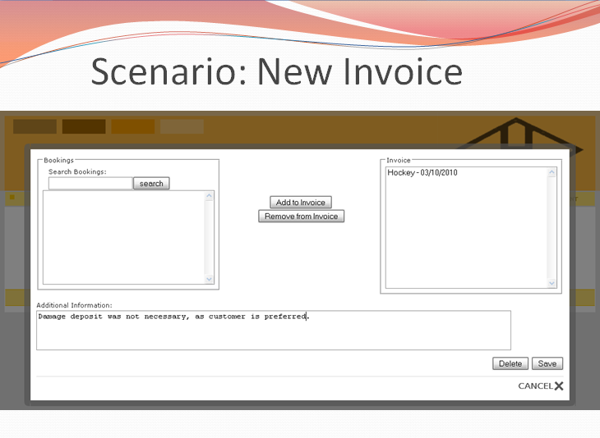

### Scenario New Invoice Continued Slide 3

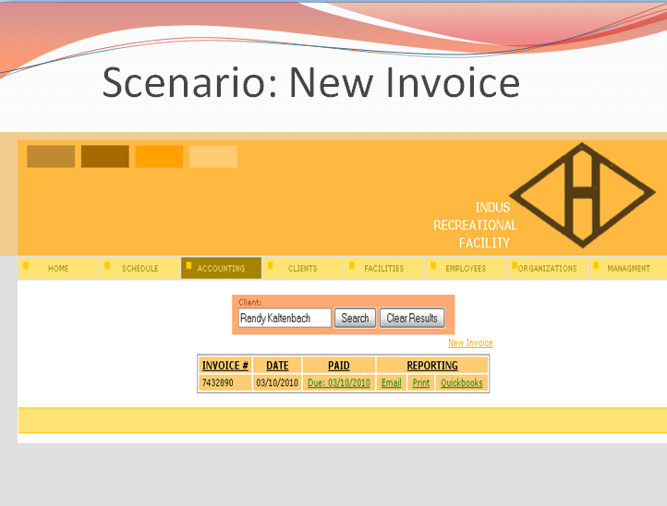

### Scenario New Invoice Continued Slide 4

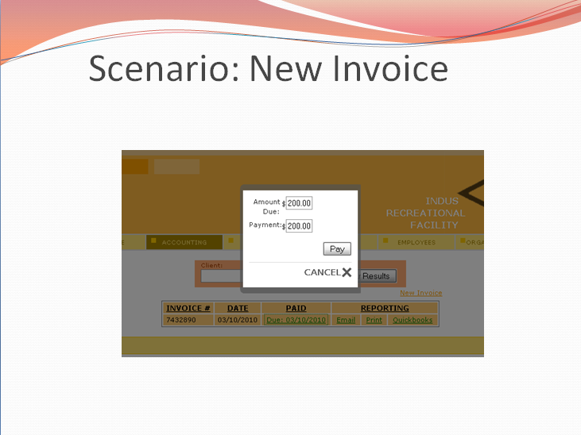

### Scenario New Invoice Continued Slide 5

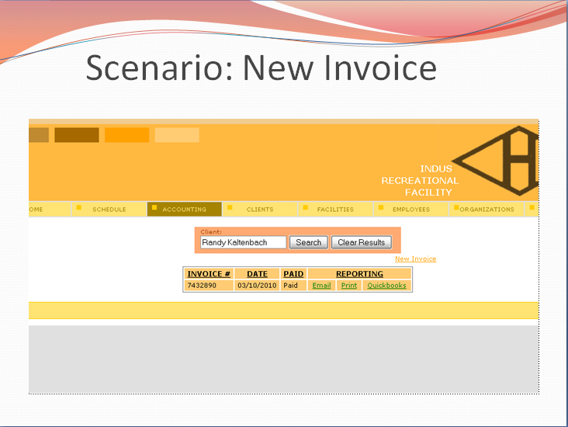

### Plan for Project Completion

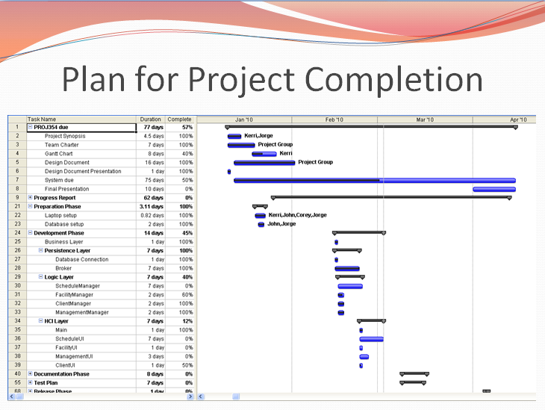

### In Conclusion

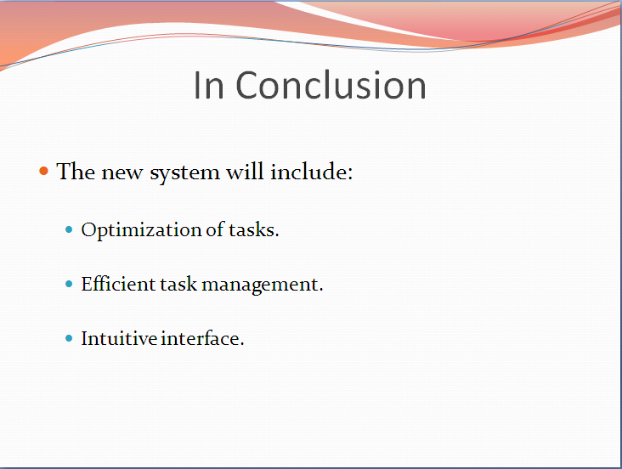

### Contact Information



### Agenda

AGENDA

**Technical Presentation**

**March 9, 2010**

**2:00 p.m. – 3:00 p.m.**

Meeting called by Indus Recreational Centre – Technical Team

Attendees: Randy Kaltenbach,

Jorge Pinochet,

Kerri Lynch-O’Loughlin,

John Stuby,

Corey Cantley

1. Introductions
2. Current System
3. New System Requirements & Design
4. Technical Challenges & Solutions
5. Scenarios
6. Conclusion
7. Final Questions

## Lessons Learned

## Technical Concepts Learned:

### Corey:

* How to use UML diagrams such as Sequence Diagrams, State Chart Diagrams, and Use Case Diagrams to aid in the development and deployment of a clean and efficient system.
* How a carefully-planned ERD helps design a good database.
* Don’t reinvent the wheel. The use of previously created tools and frameworks to speed up the development of the system.
* How to present a number of items in a calendar format.

### Kerri:

* Creation of web interface for client login to enable clients to check their outstanding balances.
* Use of servlets and jsp’s in the creation of web interface. Learned how they increase the functionality of the page and allow information to be shared through multiple pages.
* Borland – really useful tool, being able to design sequence diagrams and having the code automatically linked is a much easier process then typing it in manually. I learned to read the help guide ☺.
* Learned how to create queries in MySQL. Having only experience with SQL and PL/SQL it was interesting to see the differences and similarities between the languages.
* Designing a database, start at the basic overview. When creating a database you don’t automatically launch into drawing out the tables with rows we need to know what the overall structure will look like first so start out with just the tables and extrapolate from there.

### Jorge:

* Creation of mock UI and database is essential during the planning stage of the project.
* Extensive knowledge about MySQL acquired during the creation of database and the alterations necessary for proper functionality of the program.
* 4 Tier architecture of software development contains a lot of message passing; however, it also helps a lot during actual control of the program.
* The UML tool Together. Incredibly knit picky software but has many uses making the proper utilization of the software important. Did I mention it’s really knit picky?
* Use of a new for loop (ex// (Booking booking : bookings)
* Utilization of Tomcat
* Utilization of Putty
* PHPMyAdmin for the management of MySQL

### John:

* Utilization of putty
* Utilization of tomcat
* The importance of JUnit testing throughout the entire design phase.
* Using PHPMyAdmin for the management of MySQL
* Creation of good sequence diagrams, State Chart Diagrams, and Use Case Diagrams to help with the development and deployment of an efficient system.
* Understanding how to use Borland in an efficient way when creating diagrams.
* Learned how to properly outline a database before actually creating it.
* Understanding the importance of creating a good ERD diagram to create a database.
* Learned how to properly document code for an entire system

## Managerial Concepts Learned:

### Corey:

* Gantt charts are an important tool in managing project progress.
* Delegation of tasks to multiple team members at a time, so more than one person is able to work on a single part of the system.
* Keeping in contact with other group members and staying up to date of their progress and any pitfalls they have encountered.

### Kerri:

* Encouragement is often the only tool you need in getting work done.
* Other peoples ideas can work just as well as mine. It may not be the way I usually do things but the job gets done which in the end is all that matters.
* If you don’t have something positive to say then rephrase it and make it positive, work gets done a lot quicker ☺
* Progress reports are essential to any project. They keep you on track of your tasks and let you see who is struggling and needs help. Also helps to show the Project Manager who is not doing their share without any of the team having to.
* Gantt charts are harder then they look. Great tool but proper utilization of them is the key and I never got to the point where we got it completely correct.

### Jorge:

* The proper group dynamics are necessary for the completion of projects. Everyone is required to sacrifice and work as much as every other team member without exception was incredibly lucky to have such a great team.
  + Interpersonal Skills.
* Management of team members is key. Namely assigning work and setting deadlines to the group members less inclined to work. This increases their efficiency considerably as well as keeps progress on schedule.
* I learnt that progress reports are important to maintain group functionality.
* Gantt charts are an ineffective method of maintaining progress because they are easy to deceive and mislead.

### John:

* Management of team members to ensure fair and equal distribution of the workload.
* Progress reports are an essential to any project.
* Learned the importance of giving a clear, relaxed progress report.
* Learned how to create an easy to read progress report and Gantt chart that would meet the needs of a client.
* Learned how to give a professional presentation to a live audience in an effective manner.
* How to maintain a leadership role in a group and assign work in an effective manner.
* Got a better understanding of how Gantt charts are important tools in progress management.
* Keeping in contact with the group at all times to ensure that everyone knows the tasks they are assigned

## Recommendations for Future Enhancements:

### Corey:

* More reporting functions, such as the facility use, available time for a facility, etc.
* Have a rate automatically assigned based on what time the booking is at.
* Proper handling of catered bookings.
* Search functionality in the Schedule Information pages.
* The ability to quickly add or view information in separate areas of the system. (e.g. When creating or viewing a booking, being able to add of view a client.)

### Kerri:

* Extra functionality in the client webUI. Allow clients to change their address, phone numbers and emails. See their bookings and print a calendar of what event is booked on what date.
* Manager reports – what facilities are being used, what clients haven’t paid
* Backup and recovery of the database – be able to recover data from last week or an hour ago.
* In scheduling – be able to quickly add a client while making a booking

### Jorge:

* Dynamic additions to the system. Basically the ability to add new information to the system while creating a booking.
* Booking search needs to be implemented.
* Implement employee levels for added security and lessen user error
* Implement the restrictions that rates are detailed for
* Proper use of Borland in third semester would greatly enhance the speed and quality of coding and marks

### John:

* More efficient and effective JUnit testing to ensure easy maintence
* Implement employee levels for added security
* Backup and recovery of the database, be able to recover data from a specific time, such as a week ago or yesterday.
* Implementation of ToDoItem Broker and manager to enhance the system

## Future Enhancements:

### Items not designed or developed:

* ToDoItem Broker and Manager are designed but have not been implemented for the system.
* Employee level was not completely implemented
* Client accessing to the system is not designed or developed
* Proper handling of catered bookings was not designed

### Bright Ideas:

* Having a rate automatically assigned for a booking based on what time the booking is made.
* Creating manager reports to show what facilities are being used.
* Search functionality for pages that contain schedule information
* Enabling users to dynamically add new information to the system while creating a booking.
* Implement the restrictions specified for rates